WHITCHURCH RURAL PARISH COUNCIL

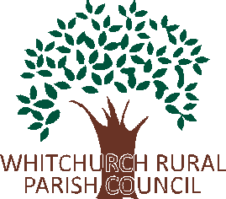

Dear Resident,

As spring and summer finally arrive, the Parish Council is pleased to share this latest newsletter with all residents of Ash. We want to update you on recent developments, outline what we’ve been working on, and show how the small portion of your council tax that we receive is being used.
The Parish Council continues to work hard to maintain and improve our village and its sense of community. Our five volunteer councillors all live in Ash and are committed to ensuring that residents enjoy a safe, clean, and well-maintained environment. This includes keeping public areas tidy and well lit, ensuring amenities are repaired or upgraded, supporting local organisations such as the bowling club and village hall, and raising concerns about road safety issues like potholes and speed limits.
While some matters are beyond our direct control—such as potholes, which can be reported at http://www.fixmystreet.com—we always take residents’ concerns seriously and do our best to follow up where possible.
Here are some of the key achievements and ongoing initiatives:
• The children’s play area has been refurbished and now undergoes a professional safety inspection every month. Any issues identified are addressed as quickly as possible.
• Litter picking equipment, including high-visibility vests, is available to residents who would like to help keep our village clean. Please contact the Parish Clerk or a councillor if you are interested.
• The pond at Ash Parva is now maintained by a team of dedicated volunteers, following a survey carried out by the Parish Council. These volunteers continue to work with our support.
• A defibrillator training session was recently organised and well attended. We would be happy to arrange further sessions if there is sufficient interest.
We also currently have a vacancy for the Ash Ward. If you are interested in getting involved with the Parish Council, please contact the Clerk for more information.
Thank you for your continued support in helping to make Ash a great place to live.
Whitchurch Rural Parish Council

